**Online Application Title: Online Movie Ticket Booking.**

**Group No.: 23**

**Team:**

**Kapil Lakamote (230345920047)**

**Anuja Suryawanshi (230345920017)**

**Prachi Jadhav (230345920038)**

**Ankit Tayde (230345920107)**

# System Diagrams

## Activity Diagrams-

**Admin Activity -**

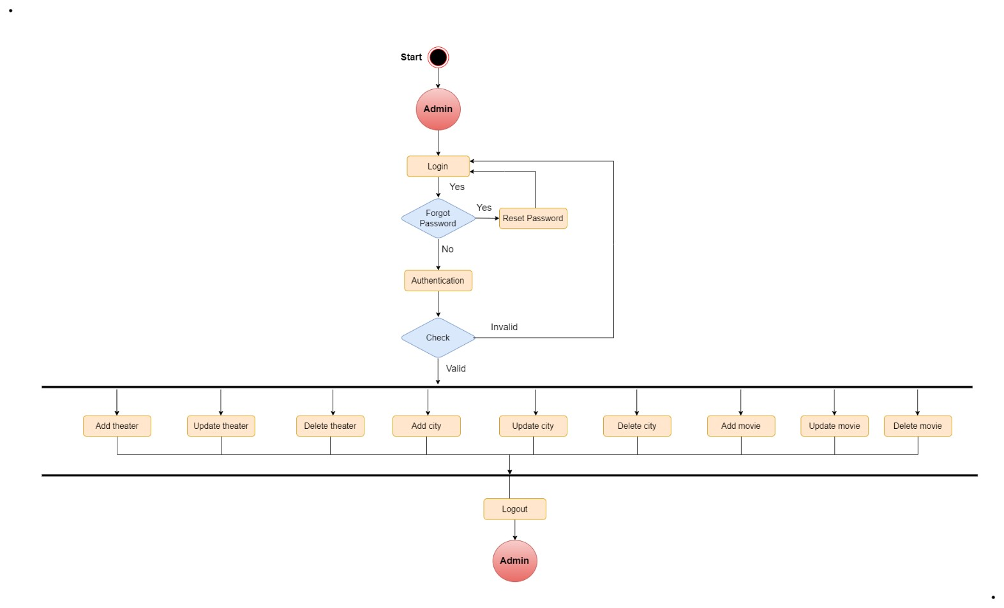

**User Activity -**

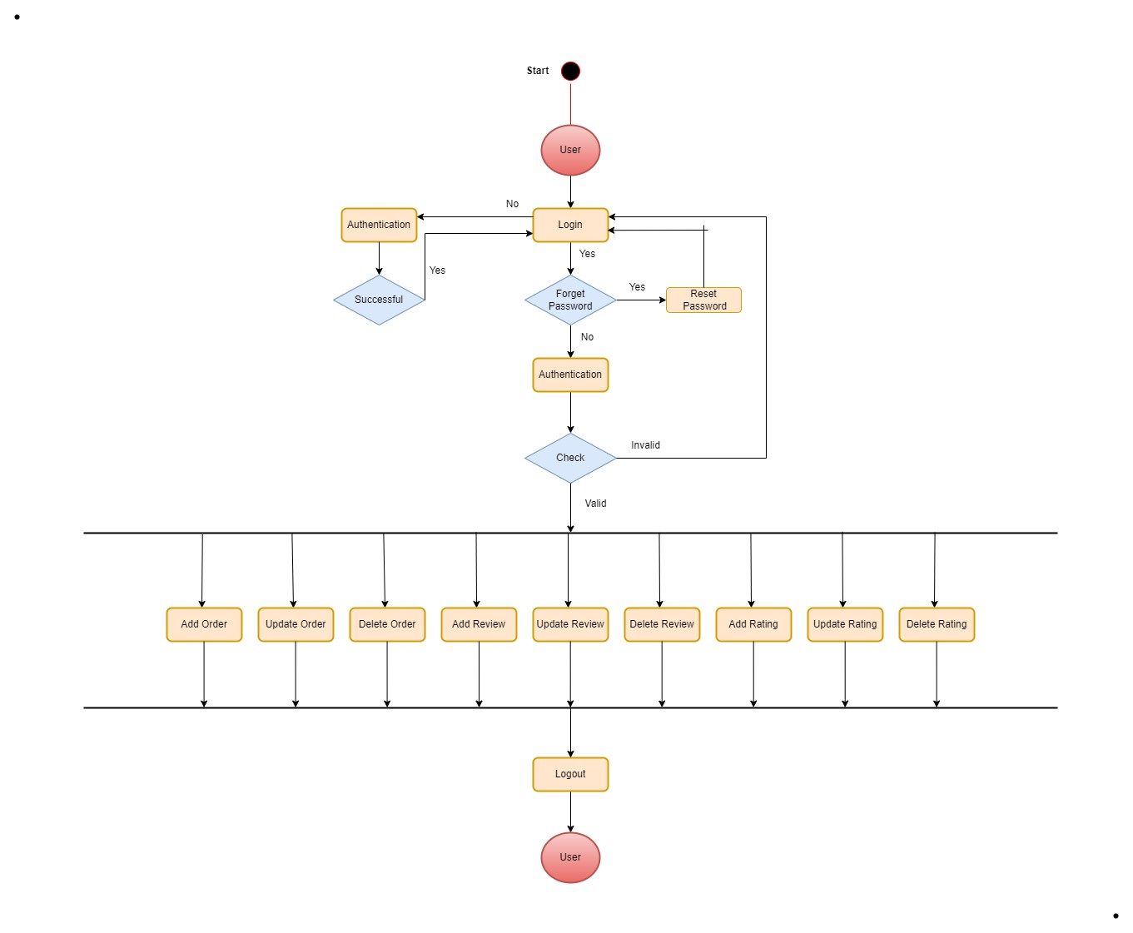

## Data Flow Diagrams –

Zero level DFD

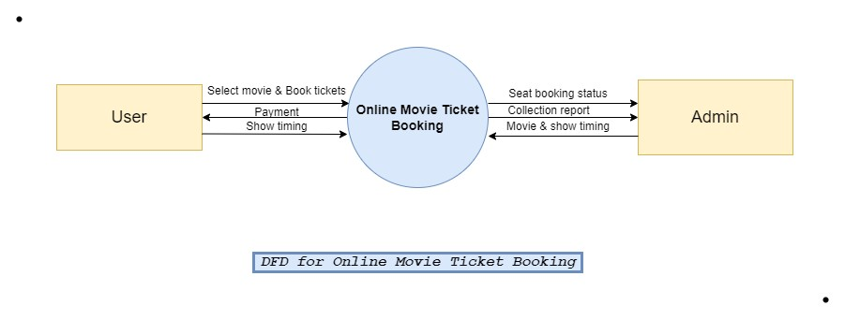

First level DFD

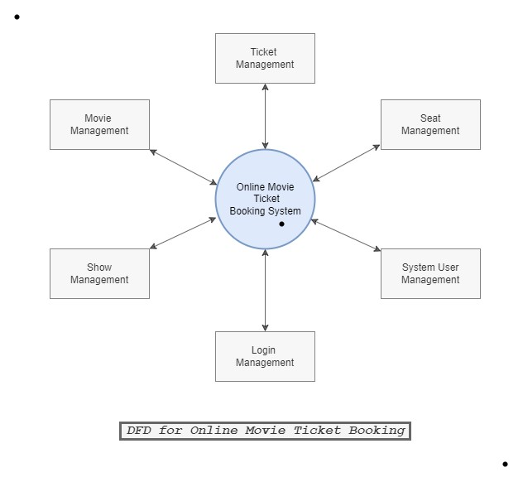

## Use Case Diagram –

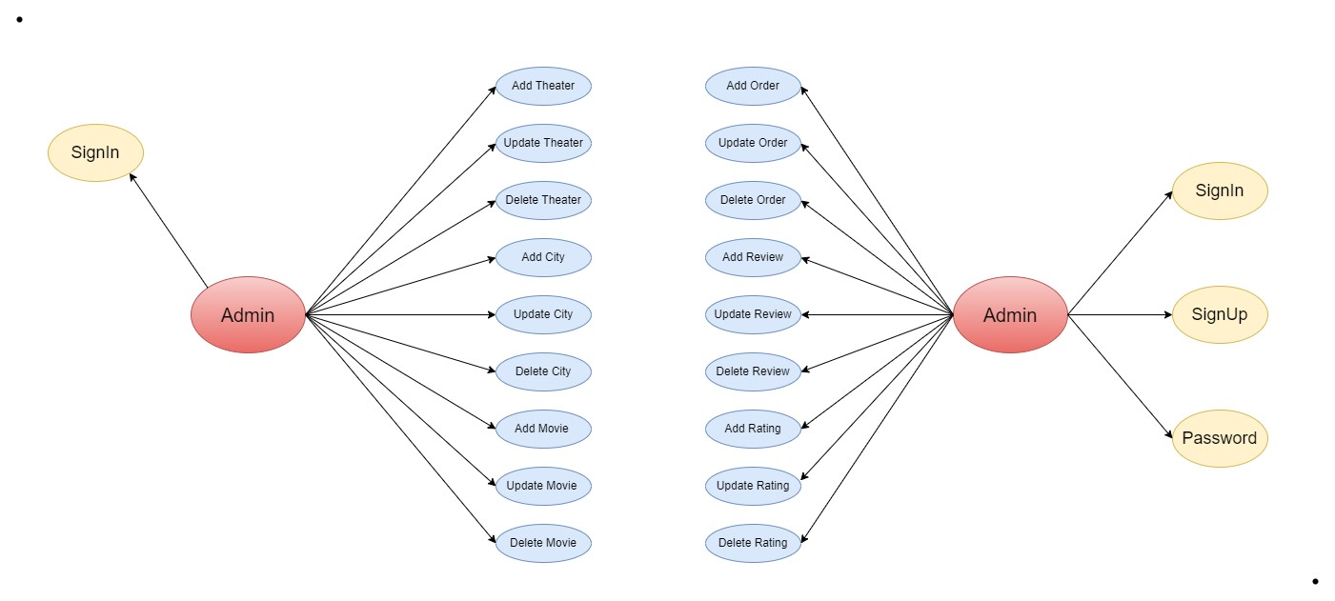

## Class Diagram –

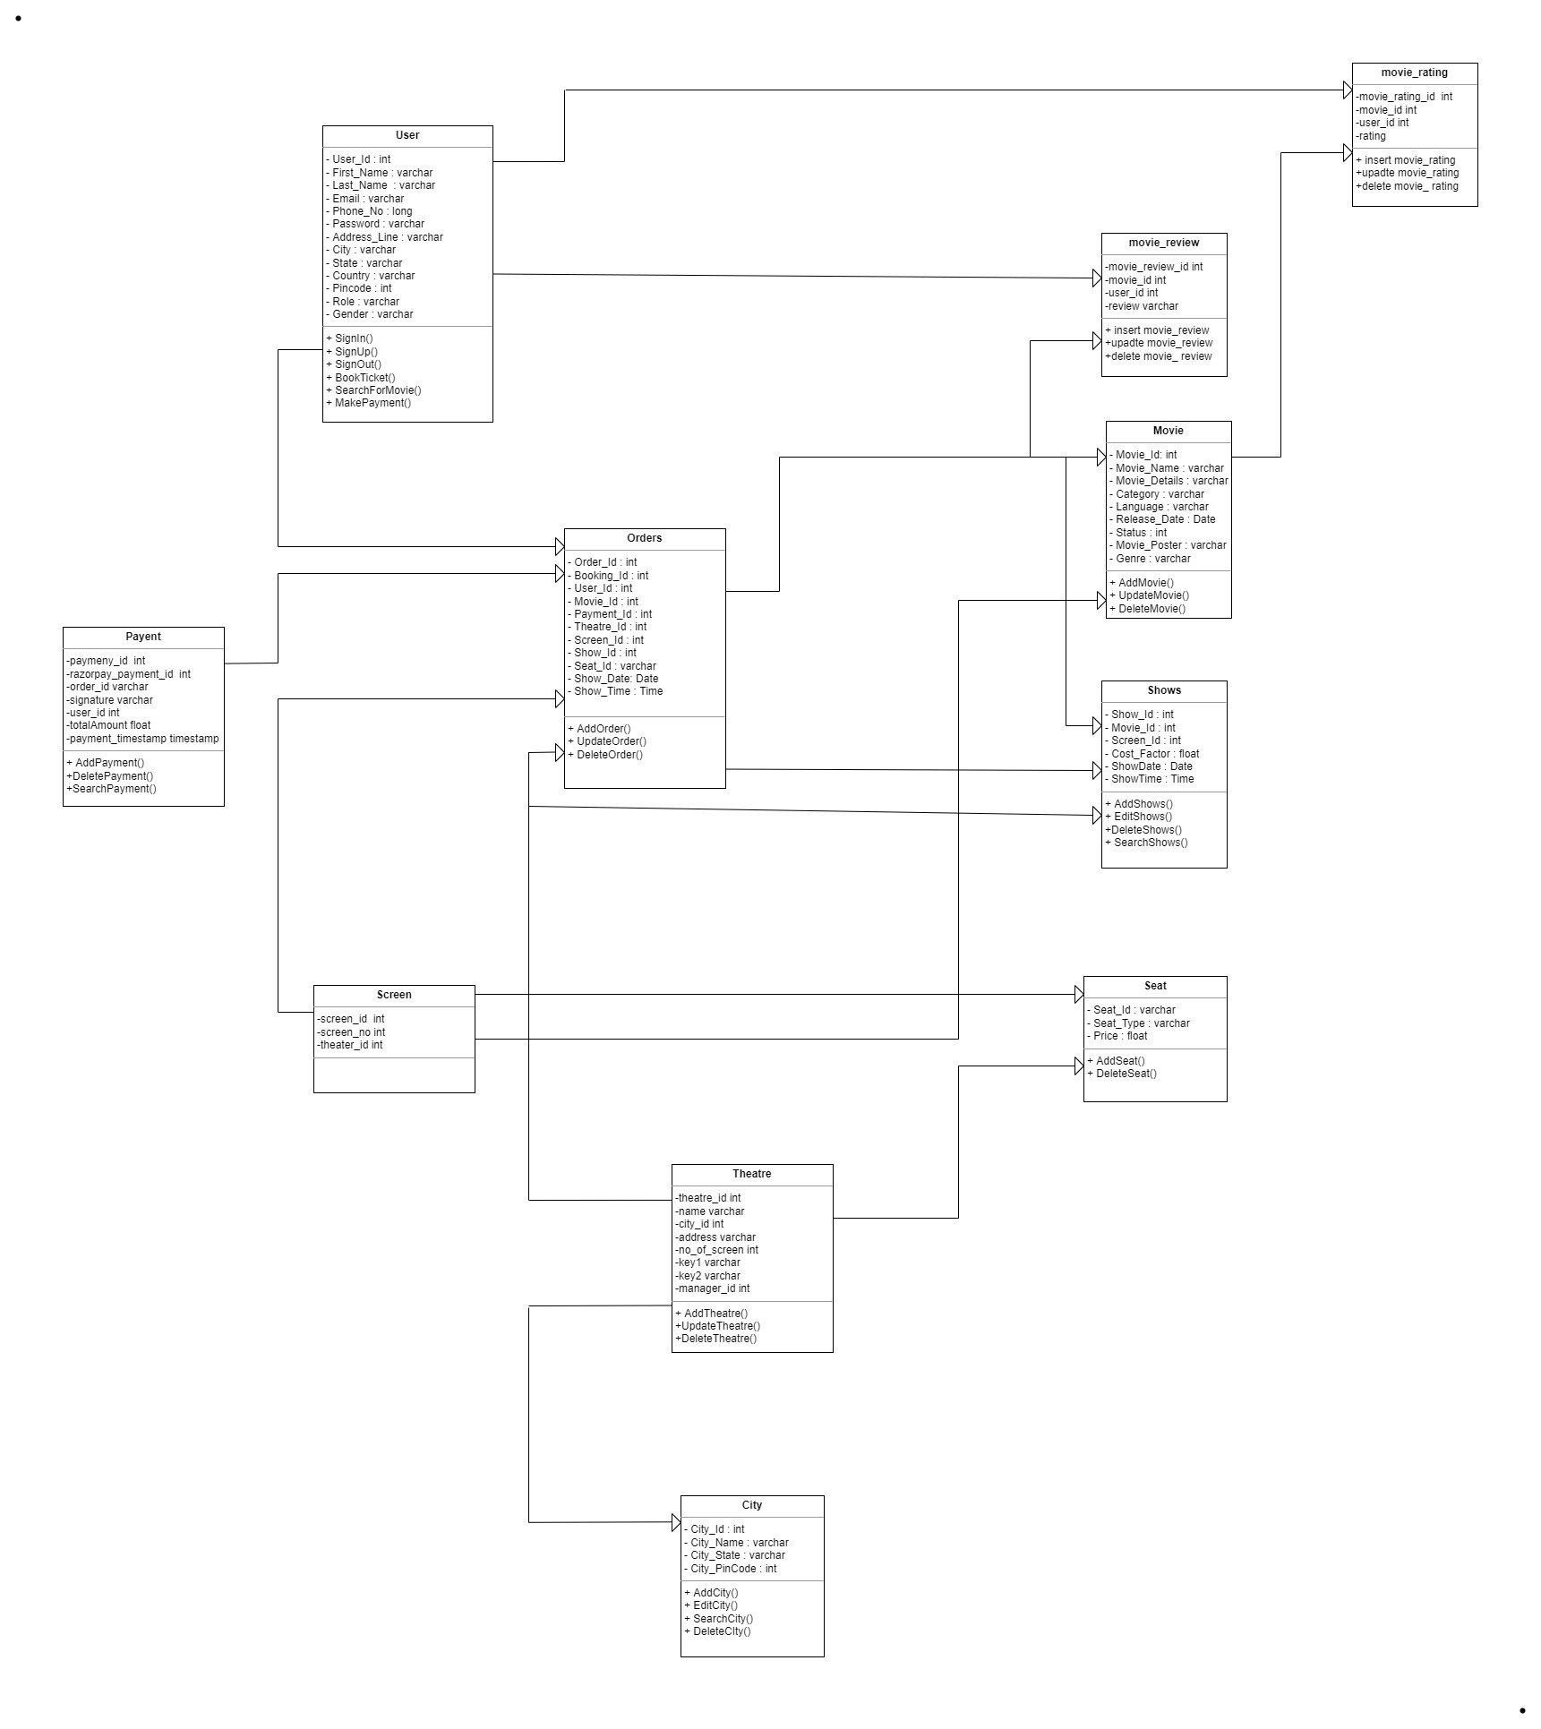

## Table Structure

### • User table-

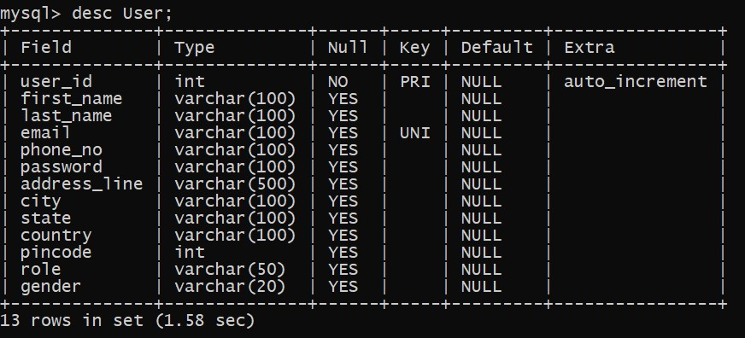

### • Movie table-

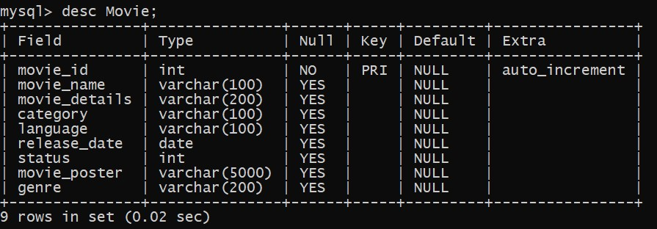

### • Movie_rating table-

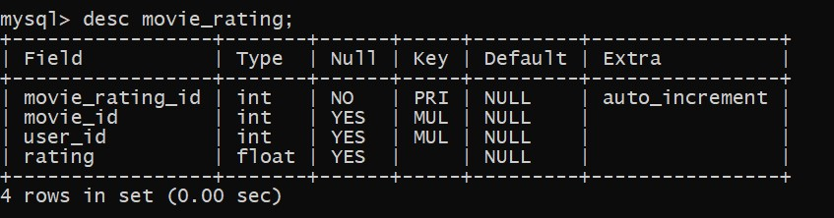

### • Movie_review table-

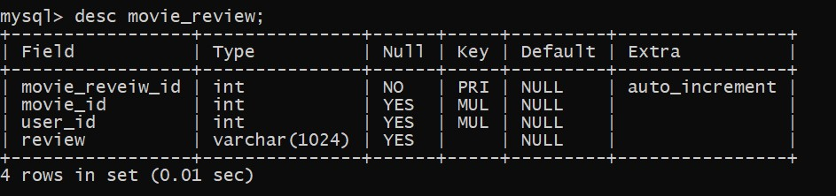

### • City table-

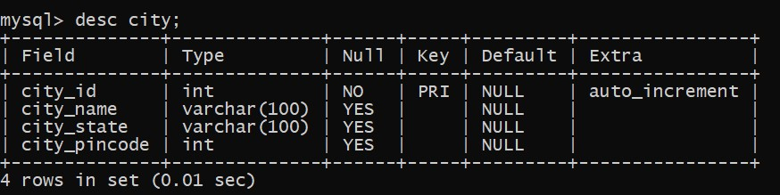

### • Theatre table-

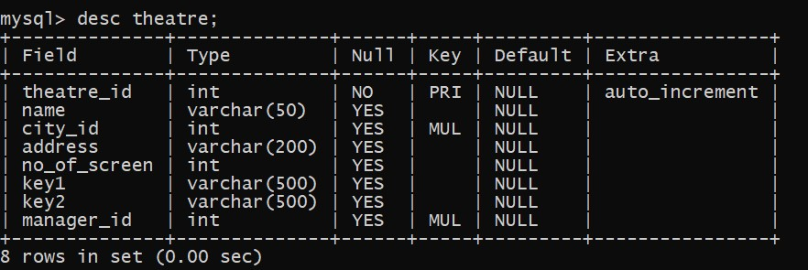

### • Screen table-

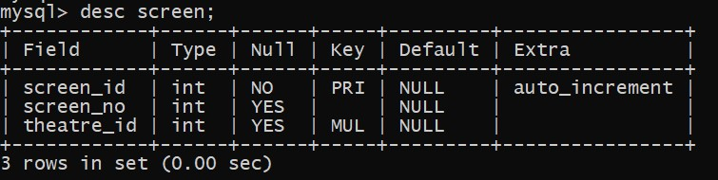

### • Shows table-

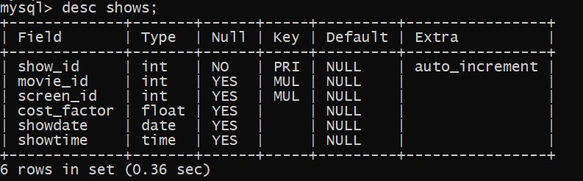

### • Seat table-

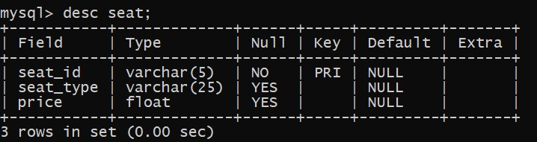

### • Seat_booking table-

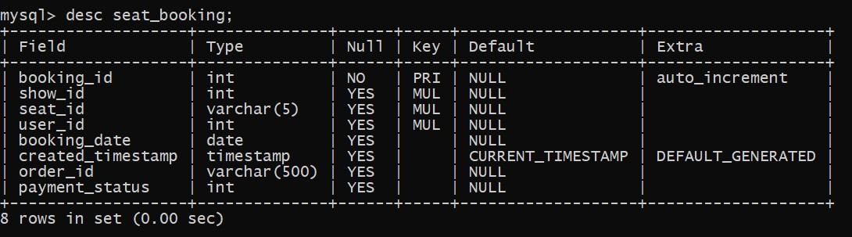

### • Payment table-

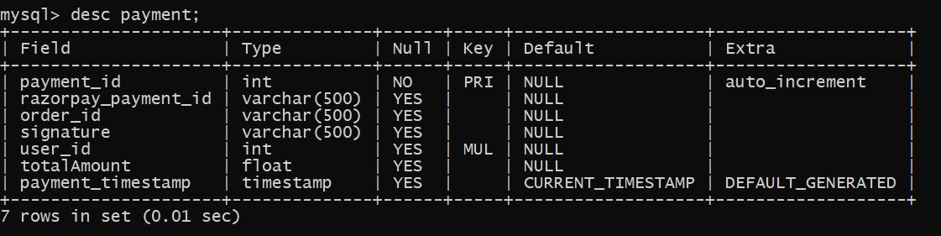

### • Orders table-

